Asset Management with Barcode tagging system for Operations and Maintenance

By:

Adrian D. Tobias

Joanna D. De Guzman

Miguel S. Mayor

Table of Contents

1. Introduction………………………………………………………........2
   1. Project Context……………………………………………………2
   2. Purpose and Description…………………………………………..2
   3. Objectives……………………………………………………........3
   4. Scope and Limitations…………………………………………….3
2. Review of Related Literature…………………………………………….4
3. Technical Background…………………………………………………...8
4. Design and Methodology………………………………………………...9
5. Appendices……………………………………………………………...10
   1. Entity Relationship Diagram……………………………………..10
   2. Data Dictionary…………………………………………………..11
   3. Context Diagram…………………………………………………11
   4. Diagram 0………………………………………………………...12
   5. Diagram 1………………………………………………………...12
   6. Diagram 2………………………………………………………...13
   7. Diagram 3………………………………………………………...13
   8. Event Table………………………………………………………14
   9. Use Case Diagram………………………………………….....….15
   10. Class Diagram……………………………………………………15
   11. Object Diagram…………………………………………………..16
   12. State Diagram…………………………………………………….17
   13. Timing Diagram………………………………………………….17
   14. Sequence Diagram……………………………………………….18
   15. Communication Diagram………………………………………...19
   16. Activity Diagram………………………………………………...20
   17. Package Diagram………………………………………………...21
   18. Composite Diagram……………………………………………...22
   19. Use Case Fully Developed……………………………………….23
6. Bibliography…………………………………………………………….35

**Abstract**

In handling bulks of weather stations and their data, effectively organizing and handling data is significantly important to reduce data redundancy and data loss. To achieve efficient organization and handling of data, implementation of an Asset Management System is important to be able to keep information about the weather stations such as ID number, weather station name, location, etc. Also, a Preventive Maintenance System is strictly recommended to be implemented to, as the name implies, prevent the weather station from malfunctioning or having errors occur. This study will explain the benefits of implementing an asset management system, as well as a preventive maintenance system in the Operations and Maintenance Department of Weather.ph to efficiently and effectively handle the data and information about the weather stations of the company around the regions of the Philippines.

1. **Introduction**

This study focuses on the creating a software solution that would improve upon the old existing system for the company called Weather.ph. What is Weather.ph? Weather.ph is a company under Aboitiz Equity, and its primary goal is to make all the people in the nation aware about the weather in the different regions of the Philippines. For example, there is a possibility of raining in Cavite while it is partially cloudy in Pasay. They want the people to be aware of the weather climate here in the Philippines. The weather station gathers the humidity reading, temperature reading, and pressure reading using different sensors that are connected to the weather station module. After gathering the data, it is transferred to a data converter through a text message. After the text message containing all the information about the readings is converted, it is then saved to the database. They gather information from weather stations that are designated in different regions in the world. The weather station sends text messages to a data converter which converts the text message to usable data for the company. Also, they handle the installation and operation of the weather machines.

* 1. **Project Context**

In the Operations and Maintenance Department of the company called Weather.ph, they handle the data of weather stations and do maintenance on the machines. There are over hundreds of weather stations which are located all over the regions of the Philippines. From the farthest point in the north which is in Itbayat, Batanes to the farthest point in the south which is in Sulu holds weather stations that delivers important data. But there is a specific problem which arises inside the department and that is their arrangement and management of data. They’re still using Excel as a means of arranging the information of the weather station. The problem is that it could result to data being overwritten since the excel file containing the weather station data is being passed through email. This generates many copies of the same file and if changes are to be made, the updated excel file should be sent to others to keep track of the updated file. Their data and documents about weather stations are just backed up in the manager’s computer, therefore creating a security issue which could result to sensitive data to leak out.

The Operations and Maintenance Department needs a new system where in their data and documents are arranged and managed in a way where in there is order and no confliction in productivity occurs. Another feature of the system could improve work flow of the department therefore increasing the productivity and providing room for improvements.

* 1. **Purpose and Description**

The study on how to arrange and manage data will result in a method which will solve the problem that the Weather.ph is now facing. This method, which is an Asset Management system with a barcode implementation for the unique identification of each weather station placed all over the Philippines, when applied to a system would significantly improve the ease of arrangement and management of data within the company. The system will not only bring productivity to the department, but also increase the reliability against the loss or errors that could occur from the data and documents that they handle.

* 1. **Objectives**

The researchers of the study have decided that the following are the main specific objectives of the study:

- To improve the way of handling the maintenance to a better and faster way

- To come up with a proposal of usable methods that can lead into create a software that will solve the problem of Weather.com.ph completely

- To create a software solution which solves the inefficiency in the Operations and Maintenance department

* 1. **Scope and Limitations**

The department that will be using this system are the operations & the maintenance department. The study will not cover other departments such as financial department, Human resources, etc. This system is limited to the operations & maintenance department. This study is also limited to the improvement of the old system by proposing a new software solution, which provides convenience and increase in productivity in the Operations and Maintenance department of the company; it does not focus in other problems in the company. The technology used in this study is limited to Weather station and the proposed software solution as well as the components of the software solution. The actors involve are the Technicians, Technician Head, Data Quality Team, Weather Station and Site Manager.

1. **Review of Related Literature**

**Weather Stations**

Weather stations are devices used by several weather-related companies that, as the name implies, collect data that are related to the weather and environment. These weather stations use multiple sensors to be able to forecast and analyze weather. The sensors that are usually included in a weather station are barometers that measure the atmospheric pressure, thermometers to measure the temperature, hygrometers that measure the percentage of water vapor in the air or humidity, wind vanes that could tell the direction of where the wind is blowing, anemometers that measures current, peak, and average wind speeds, rain gauges that measures rainfall, and several other sensors depending on the manufacturer. Weather stations aren’t just for professional use, there are also weather stations being sold for home use. (Acurite, 2010)

Weather stations also come in two main types, manual and automatic stations. Manual weather stations are the traditional weather stations which are analog when measuring certain weather data. On the other hand, automatic weather stations, or AWS, have two main parts which are outdoor and indoor. The outdoor components of an AWS are the sensors that collect weather data, which then is sent to the indoor component of an AWS that displays the measurements and readings of the AWS. Many people, up to this day, still use the traditional manual weather stations, while many companies have migrated to the usage of an automatic weather station. One difference between a manual weather station and an automatic weather station is cost, with the latter being more expensive. (Moore, 2016)

**Barcode Systems: Extend the Enterprise**

Barcoding, or barcode system, is a form of collecting data and an identification tool which does not require the use of physical keys. Barcodes are the black bars with gaps which are parallel that hold data contained in binary coding. Barcodes nowadays also come in other shapes such as rectangular ones. Each individual barcode has a unique pattern or shape that can correspond to an item or object. These barcodes are read using optical lasers which can interpret numerical and alphanumerical characters. According to Zebra Technologies, several forms of manual data collection and data entry has been replaced by the barcoding system. This is because the speed, as well as the accuracy, at which data is retrieved by barcoding is extremely quick and accurate. Zebra Technologies state that these barcoding systems are accurate 99% of the time. This is important due to the fact that data entry errors could cause negative effects on a business such as a wrong input of data within a manufacturing company could cause a decrease in production due to wrong values. (Zebra Technologies, 2013) Barcode technology could greatly impact the back-end of a business for numerous reasons. One of which is an improvement of the accuracy of data. This alone could possibly be the main intention for implementing a barcode system. The reason for its accuracy is due to the fact that the information are kept within the individual barcodes itself in which almost no human error could occur. According to BarCode ID Systems, the implementation of barcoding could greatly decrease operating expenses and have a noticeable return of investment with 6 months. Research also shows that barcode could increase warehouse operations inventory accuracy to about 99%. (Barcoding Inc., n.d.)

**RFID vs. Barcodes**

RFID, or Radio Frequency-Identification technology, is another type of tool used for data collection and uniquely identifying an item, similarly to barcodes. RFIDs contains a tiny chip and an antenna. As the name implies, RFIDs use radio frequencies to communicate with an RFID tag, or a transponder that contains information, which is interpreted using a transceiver that could interpret data. On paper, RFID is more sophisticated than barcodes with features such as farther read distances, faster read and write speeds, larger data capacity, higher levels of security, and many more. RFID systems also have their downsides though. Its drawbacks include higher pricing since it contains a computerized chip, and reader and tag collision errors when multiple readers and tags could cause errors to one another. (adaptalift, 2012)

**The Advantages of Preventative Maintenance**

Preventative maintenance is maintenance that is regularly performed on a piece of equipment to lessen the likelihood of it failing. Preventative maintenance is performed while the equipment is still working, so that it does not break down unexpectedly.

According to Stuart Smith of MINTEK, many companies still do not consider applying preventive maintenance to their equipment and only acting when the actual equipment has broken down or failed, causing expenses to rise for the company for the replacement of the broken equipment. Preventive maintenance has several advantages, one of which is that preventive maintenance could decrease the expenses of the company. Even though preventive maintenance is also expense for the company, the cost of preventive maintenance is lower, compared to the actual replacement of the same equipment. The second advantage is the increase of efficiency of the equipment, making the equipment run more cost effectively. Equipment that has 100% health would utilize energy or power resources better than low health equipment. Preventive Maintenance could also indirectly increase the reputation of the company. Since the goal of preventive maintenance is to reduce the likelihood of a failure to occur, the company's history or track record of failure in their equipment would be minimal to none. (Smith, 2012) Preventive maintenance lessens the number of large-scale repairs as well as improves the safety and quality conditions of the people working with and around the area of the said equipment.

**Six Steps to Design a Preventive Maintenance Program**

According to Ken Staller of Daniel Penn Associates, there are six steps to devising a preventive maintenance program. The first step of preventive maintenance is by reverse engineering what the company want to achieve by designing the procedures and identifying the possible problems or failures that may occur to the equipment. Also, the architects of the preventive program must be knowledgeable of the equipment or machines, they must know how it works and what to do at failure of the equipment. The second step of devising a PM program is to know how to efficiently handle the use of people and resources. First, the company must have a Computerized Maintenance Management System, or CMMS, in order to effectively handle the data about the people and resources, and the procedures. Next, the right procedures must be written and sent to the CMMS. After that, these procedures must be scheduled. The 3rd step is proper preventive maintenance lubrication engineering. This step is basically proper maintenance of lubrication of the equipment, and handling oils and grease as well as proper disposal of these oils and greases according to the environmental rules depending on the area. The fourth step is to train the staff for correct and proper preventive maintenance. Make sure the staff knows how to operate, repair, and maintain equipment according to how they were trained. The 5th step is having a management plan for the PM program. A proper management plan is effectively attaining information that could be useful for future analysis. Such information includes labor-hours, quantity of materials, reason for specific Work Order, etc. Lastly, the sixth step is to make sure communication to the workers is present. Communication is key in almost all programs and systems. Not having communication to the workers could cause misunderstandings to as why they are required to do such tasks. Communication must be present so that the workers of the PM program would know what exactly should be done, who will do this certain task, and when it should be done. Also, they must know what quality of work must be done.

**Asset Management**

Asset management is basically organizing the assets of a company in order to improve efficiency and productivity as well as maintenance of the assets. According to jinisyssoftware, asset management systems make tracking assets easier and contain details which make assets more organized since this information about the assets are located inside a database which is seen in the web application of the asset management system if ever present. Benefits of implementing an asset management include improved asset tracking, improved productivity, and efficient in time handling. (Jinisys Software Inc. , n.d.)

According to the Federal Highway Administration, the proper definition of asset management, defined by Organization of Economic Cooperation and Development (OECD), is as follows:

*“[Asset Management is] a systematic process of maintaining, upgrading and operating assets, combining engineering principles with sound business practice and economic rationale, and providing tools to facilitate a more organized and flexible approach to making the decisions necessary to achieve the public's expectations. (OECD 2000)”*

FHWA explains that there are different decision levels of asset management which may interconnect and overlap because communication between the levels is important for the management process. The first and most broad is the strategic decisionmaking level wherein its concern is with broad and generic resource allocation and utilization decisions. The next level is the network decisionmaking level. This level is similar to the strategic level but is narrower since overall budget allocation is a focus area here and is broken down into the other lower levels such as program level and project selection level. After that level is the program decisionmaking level which pertains to the policy decisions and focuses on the optimization of funds in the system. The next level is the project selection level which has to do with the funding for specific projects. This level needs more specific and detailed information compared to the program and network level. The last level is the project level which is the most specific of all levels due to the fact that it has to do with the design of the project which is part of the overall work plan. It is also known as the ‘field level’ or ‘operational level’. This level also shows the actual work which is needed to be done. (FHWA, 2015)

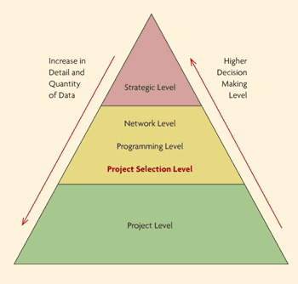

1. **Technical Background**

The system will be incorporated as a web application which will cater to the needs of the Operations and Maintenance Department since they have roaming technicians that goes to sites where weather stations are placed. This web application has the ability of having a CRUD operation on service reports of the department. Weather station location, model number, SIM number, and other information that are related to weather station are to be presented to the members of Operations and Maintenance department.

The software solution is comprised and created through the use of the Yii2 framework which is based on PHP coding. It has the functionalities of a CRUD operation on service reports and weather stations. An admin management feature is also included so that user privilege assignment is possible. This software solution serves to replace the old system of using excel as an information keeper of the weather station data. This will solve the inefficiency occurring and improve the data integrity of the information available in the department. The feature are only available to log in users and admins. Creating a record for an existing weather station is possible as well as updating the information, allowing users to view the information and deleting the record of that specific weather station. A signal part is included at the main page for the weather station feature for easy identification on what is the status of the specific weather station. The service report feature also has the available operations. The service reports contains the creation time, the information about the weather station, the end time of the maintenance, and the author of the said service report. Not only this will replace the excel file system existing in the company today, but also provide an easier way to arrange and manage the data given.

This web application will be accessed either through a browser from a laptop or a mobile phone which has an internet connection. Productivity will increase due to easier access of the needed information and improvements to the workflow of the department will happen.

1. **Design and Methodology**

The group of processes or the order of our whole system is the following:

1. Data Quality Team checks if a weather station is broken

2. If there is a broken weather station, creates a service request

3. The service request is sent to the technicians

4. Technicians will execute maintenance referring to the service request received

5. Technicians will do first solution first and if first solution doesn’t work, do second solution

6. First solution is contacting site manager for maintenance through phone and the call is recorded

7. If it doesn’t work, second solution is mandatory and it is a site visit for physical maintenance

8. Scheduling is a first before a site visit

9. After maintenance, a service report is created to mark the end of the maintenance process

10. The service report is then passed to the Operations and Maintenance Head for review and double checking for error

11. End of the process

This is illustrated by the diagrams located at Appendices part of this paper which is at page 9 to 19.

1. **Appendices**
2. Entity Relationship Diagram

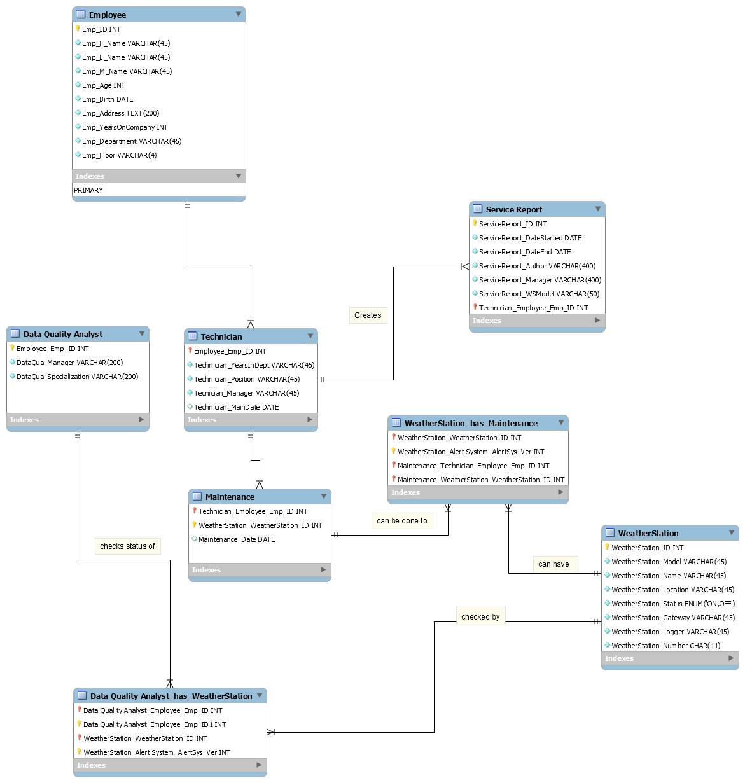

1. Data Dictionary

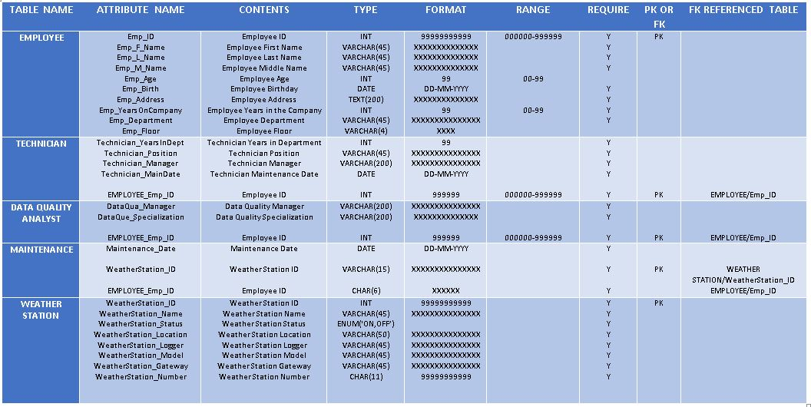

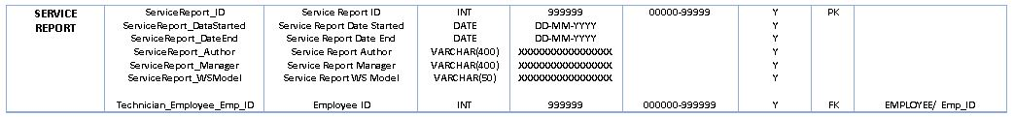

1. Context Diagram

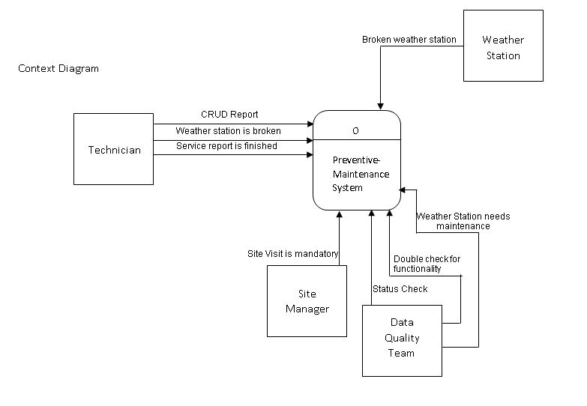

1. Diagram 0

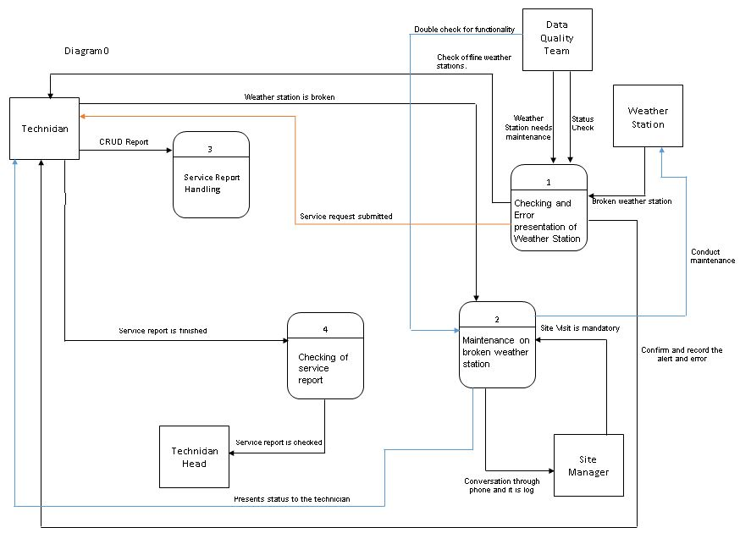

1. Diagram 1

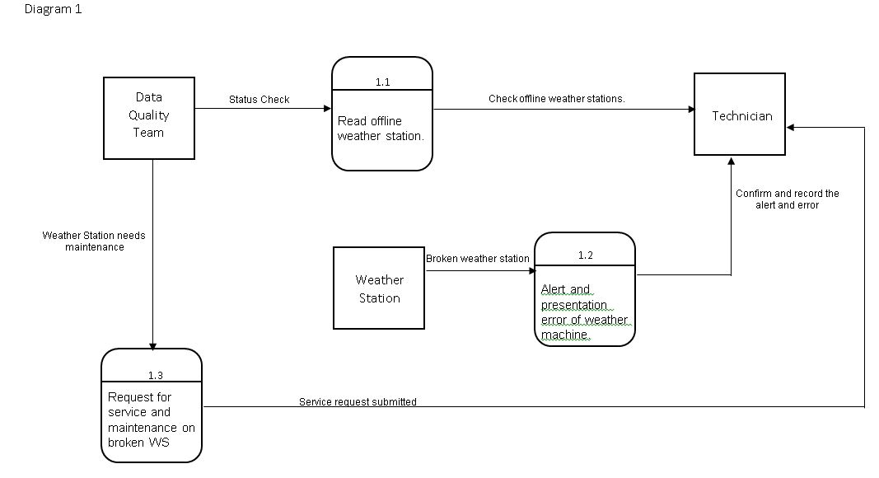

1. Diagram 2

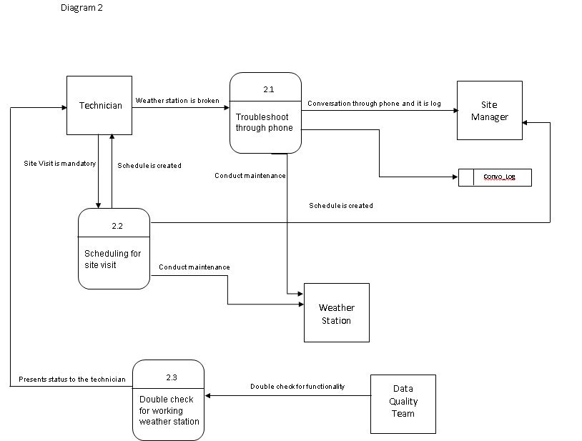

1. 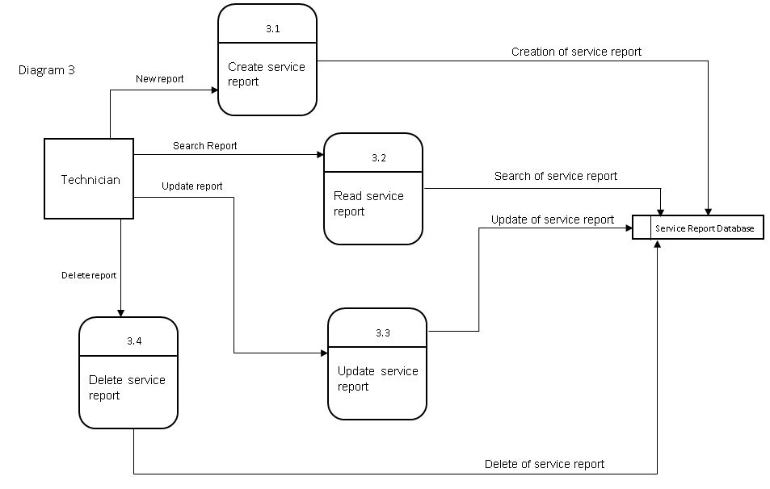Diagram 3
2. Event Table

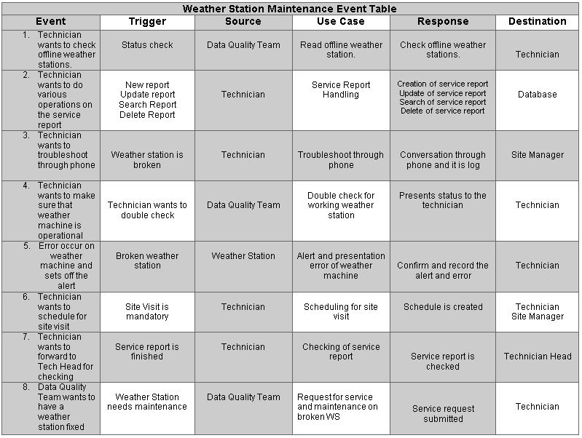

1. Use Case Diagram

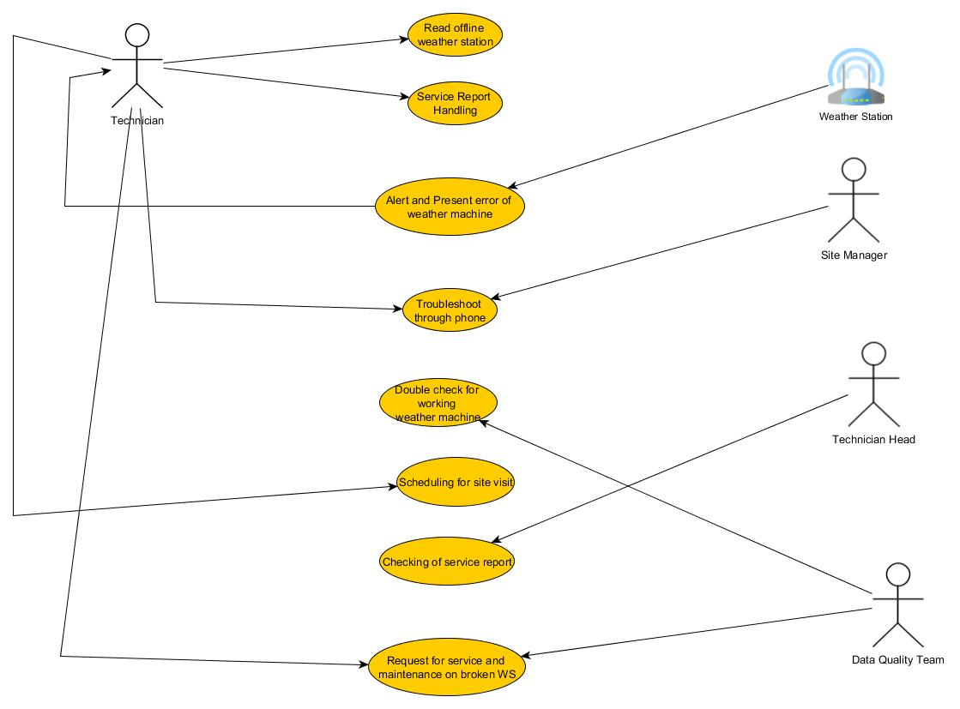

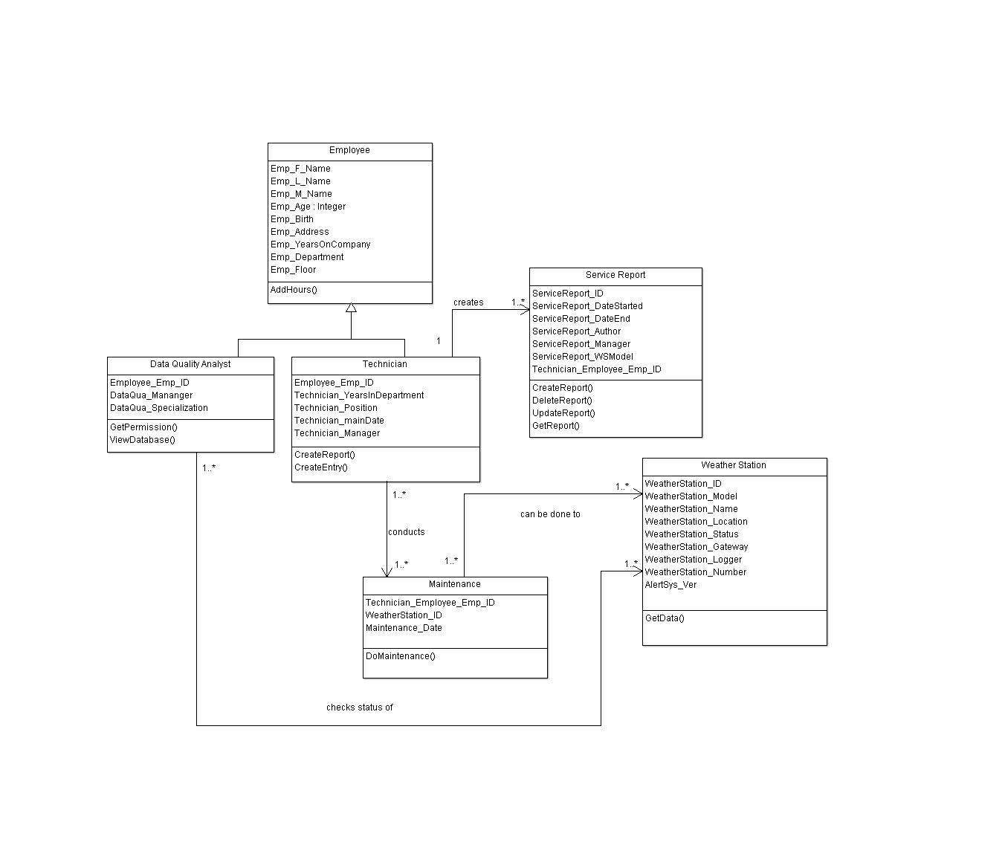

1. Class Diagram
2. Object Diagram

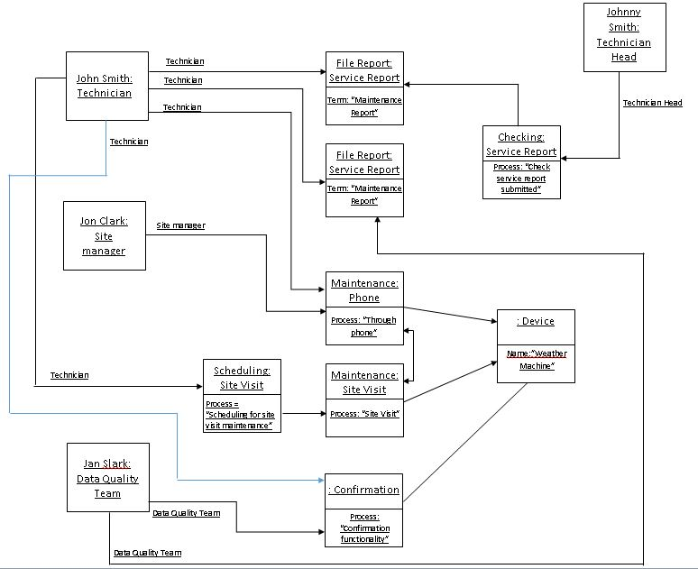

1. State Diagram

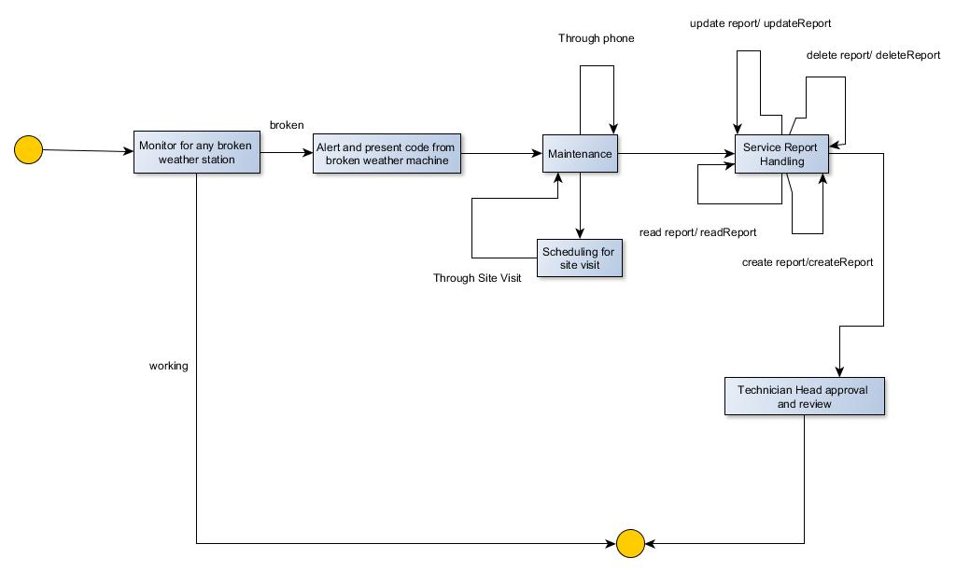

1. Timing Diagram

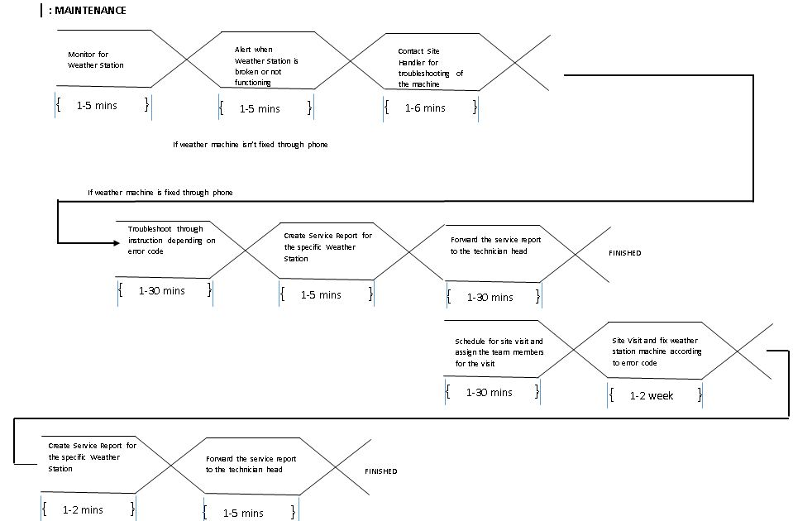

1. Sequence Diagram

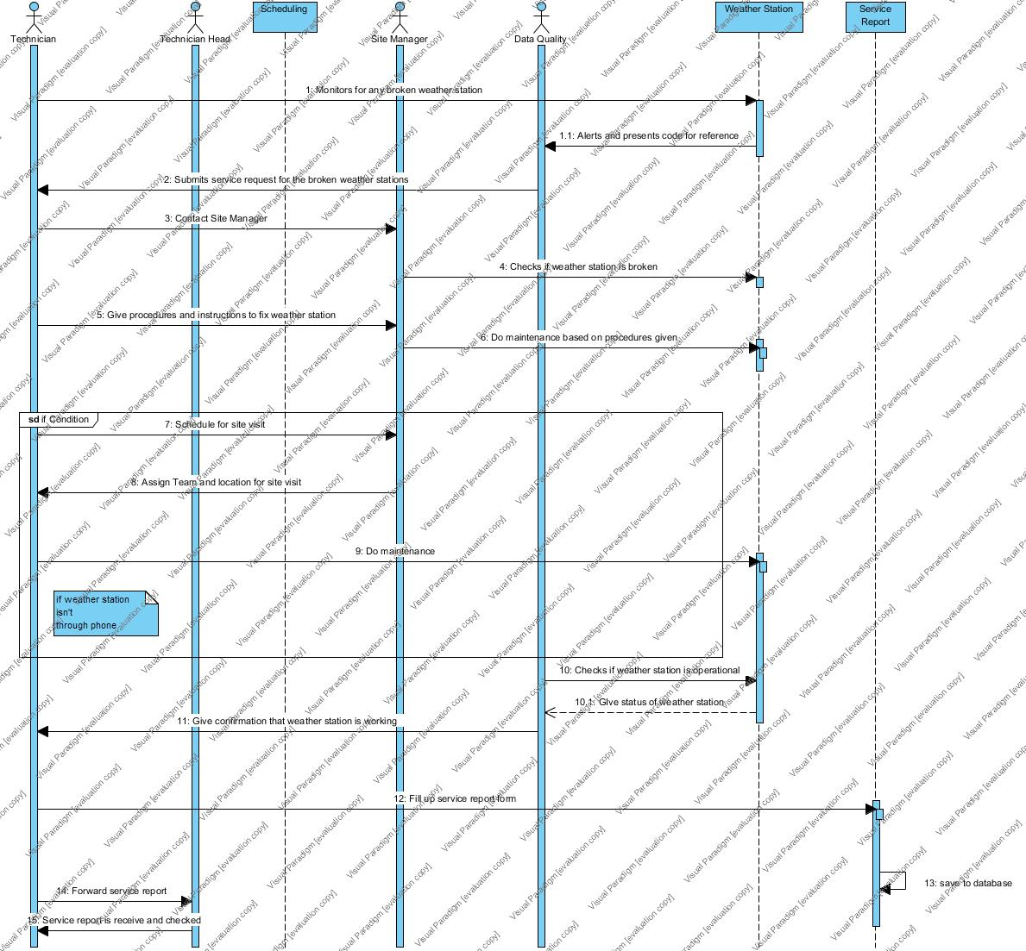

1. Communication Diagram

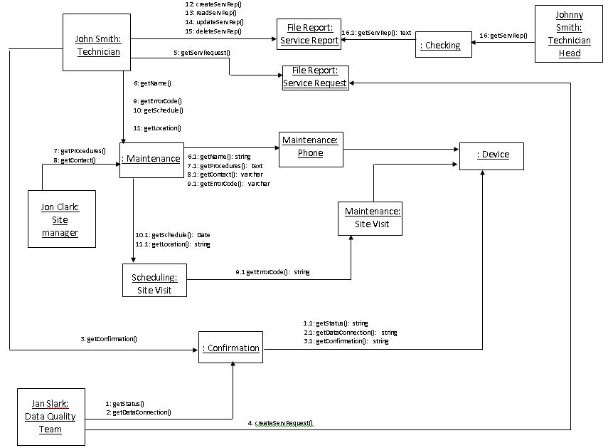

1. Activity Diagram

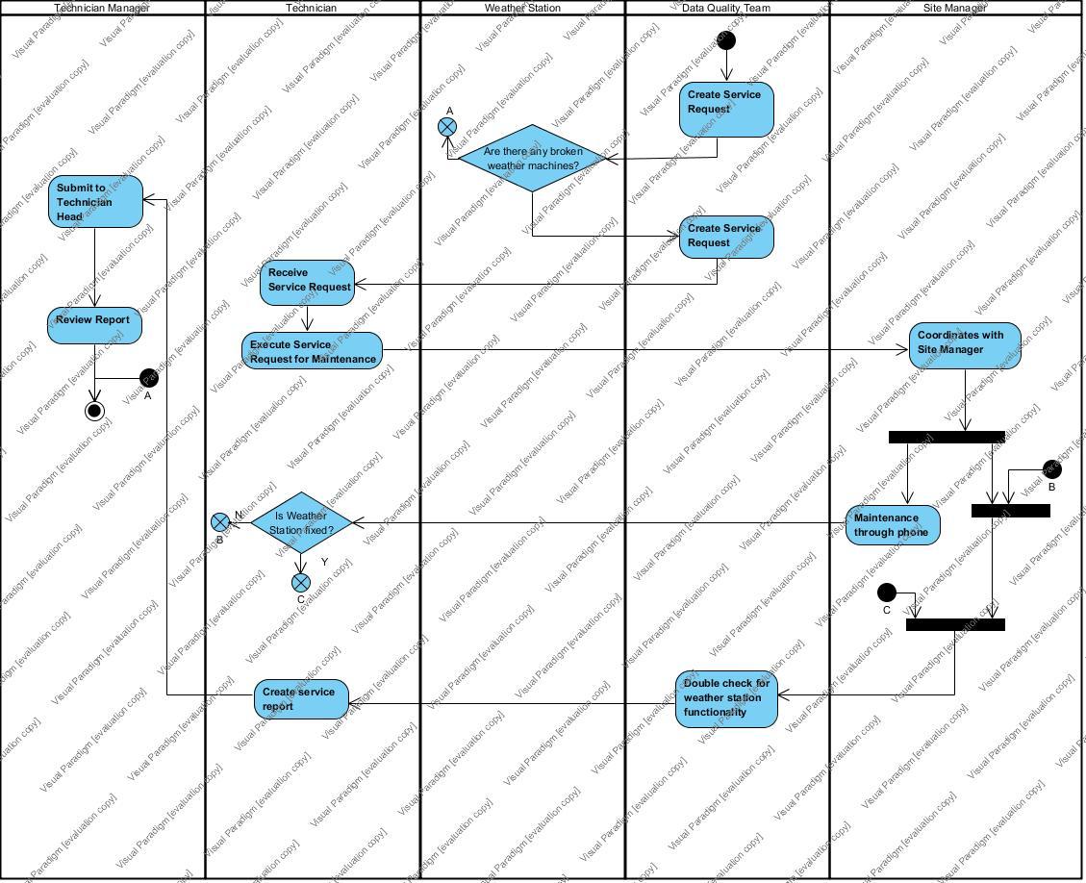

1. Package Diagram

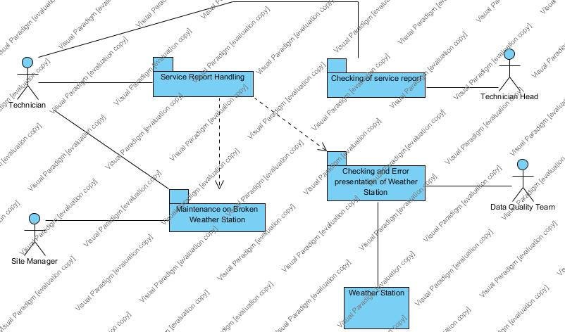

1. Composite Diagram

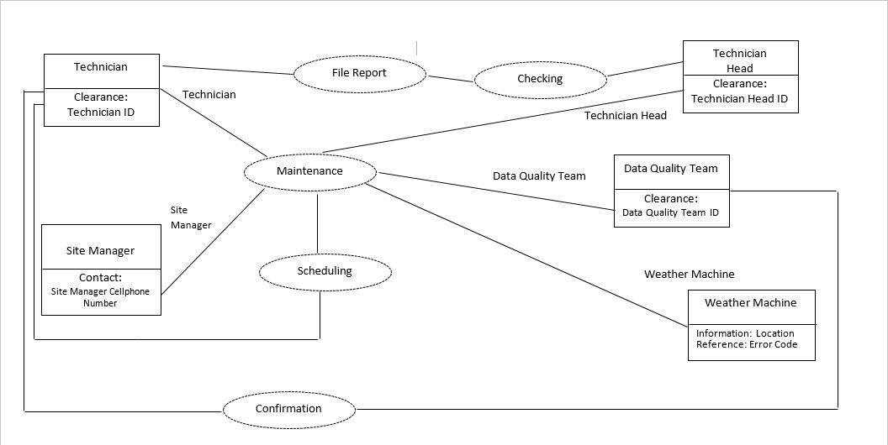

# Bibliography

Ableserve. (n.d.). *THE BENEFITS OF PREVENTIVE MAINTENANCE*. Retrieved from Ableserve: http://ableserve.com/issue-1/the-benefits-of-preventive-maintenance/

Acurite. (2010). *What is a Weather Station?* Retrieved from Acurite: http://www.acurite.com/what-is-a-weather-station

adaptalift. (2012, May 01). *RFID VS BARCODES: Advantages and disadvantages comparison*. Retrieved from adaptalift: http://www.aalhysterforklifts.com.au/index.php/about/blog-post/rfid_vs_barcodes_advantages_and_disadvantages_comparison

Barcoding Inc. (n.d.). *Barcode Systems: Extend the Enterprise*. Retrieved April 12, 2016, from Barcoding: http://www.barcoding.com/barcode/

Boissy, P., Jacobs, K., & Roy, S. H. (2006, December 21). *Usability of a barcode scanning system as a means of data entry on a PDA for self-report health outcome questionnaires*. Retrieved April 12, 2016, from Bio Med Central: http://bmcmedinformdecismak.biomedcentral.com/articles/10.1186/1472-6947-6-42

FHWA. (2015, August 3). *Chapter 1. Literature Review*. Retrieved from Federal HIghway Administration: https://www.fhwa.dot.gov/asset/dataintegration/if08018/amdc_03.cfm

Jinisys Software Inc. . (n.d.). *Asset Management System*. Retrieved from jinisys software: http://jinisyssoftware.com/asset-management-system/

Moore, C. (2016, February 26). *I want a weather station (part 1): Manual or automatic?* Retrieved from BBC: http://www.bbc.co.uk/weatherwatchers/article/35669024/i-want-a-weather-station-manual-or-automatic

Morriss Jr, F. H., Abramowitz, P. W., Nelson, S. P., Milavetz, G., Michael, S. L., Gordon, S. N., . . . Cook, F. (2009, March). *Effectiveness of a Barcode Medication Administration System in Reducing Preventable Adverse Drug Events in a Neonatal Intensive Care Unit*. Retrieved from The Journal of Pediatrics: http://www.jpeds.com/article/S0022-3476(08)00705-1/fulltext

Pepperl+Fuchs Inc. (2007, September 12). *LASER BARCODE SCANNERS FOR INDUSTRIAL AUTOMATION*. Retrieved April 2016, from Pepperl+Fuchs Inc.: http://files.pepperl-fuchs.com/selector_files/navi/productInfo/doct/tdoctb014__usa.pdf

Smith, S. (2012, September 26). *The Advantages of Preventive Maintenance*. Retrieved from MINTEK: http://www.mintek.com/blog/eam-cmms/advantages-preventive-maintenance/

Staller, K. (2015). *Six steps to design a preventive maintenance program*. Retrieved from Planet Engineering: http://www.plantengineering.com/single-article/six-steps-to-design-a-preventive-maintenance-program/15dc84630bc8dc979f8a1d9bc989cdc3.html

TechNovelgy. (n.d.). *RFID Reader Collision*. Retrieved from TechNovelgy: http://www.technovelgy.com/ct/Technology-Article.asp?ArtNum=58

TechNovelgy. (n.d.). *RFID Tag Collision*. Retrieved from TechNovelgy: http://www.technovelgy.com/ct/Technology-Article.asp?ArtNum=57

TechNovelgy. (n.d.). *What is RFID?* Retrieved from TechNovelgy: http://www.technovelgy.com/ct/technology-article.asp

Zebra Technologies. (2013). *BARCODING 101*. Retrieved April 12, 2016, from Zebra: https://www.zebra.com/content/dam/zebra/white-papers/en-us/barcoding-101-en-us.pdf